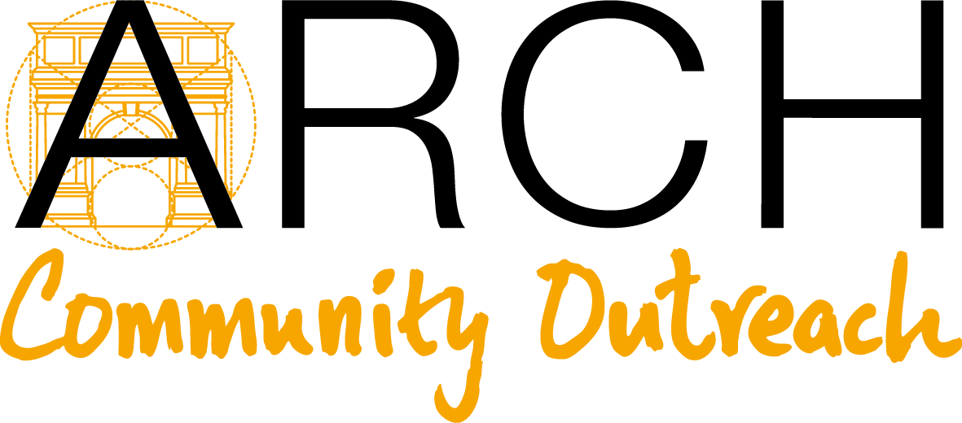
TEACHER RECOMMENDATION FORM
CAREERS PROGRAM 2021
Please return this application via e-mail or post.
ARCH Community Outreach, Unit 202-205, 2/F, Wilson House, 19-27 Wyndham Street, Central, Hong Kong
Tel: 852-3568-0406 E-mail: info@arch-community-outreach.com
www.arch-community-outreach.com

INSTRUCTIONS:
- Please complete all sections of the application form in English.
- Only completed and signed forms will be processed.

PART A: TO BE COMPLETED BY THE APPLICANT:
APPLICANT INFORMATION
Name (Last Name / First Name):
Grade / Form: |  | Age:
School: |  | Contact Number:
Gender: □ Male □ Female | Date of Birth (MM/DD/YYYY): |  | HKID No.:

PART B: TO BE COMPLETED BY TEACHER:
1. TEACHER INFORMATION
Teacher’s Name (Last Name / First Name):
Teacher’s Contact Number:
Teacher’s E-mail (Capital letters):
List the course(s) and respective form(s) you taught the Applicant (e.g. English, Form 3).

How many years have you known the Applicant?

3. TRANSCRIPT
Please provide one copy of the Applicant’s school transcript/report of the past two academic years and most recent mid-year school report. The school transcript/report should indicate courses and grades attained by the Applicant in respective semesters.
4. RANKING
Rank in Class: | Rank in Form:

5. EVALUATION
a) Please share with us anything you think is important to know about the Applicant and his/her suitability for the Careers Program. This may include family background, personal qualities and academic attributes as demonstrated in class and/or according to your assessment of the Applicant. Feel free to include any additional information that may help set this student apart from others. Please attach your evaluation to this form.
b) Please rate the Applicant in terms of:
 | No Basis/ Not Applicable | Below Average | Average | Good (above average) | Very good (Well Above Average) | Excellent (Top 10%) | Outstanding (Top 5%) | Among the top I’ve seen (Top 1%)
Academic achievement
Disciplined work habits
Motivation
Intellectual curiosity
Creative, original thought
Community Involvement
Participation in class
Maturity
Leadership
Integrity
Ability to tackle challenges
Confidence
Initiative/Independence
Respect for faculty
Respect for peers/others
OVERALL

4. DECLARATION
I confirm that the information I have supplied in this application is accurate to the best of my knowledge. I also acknowledge and hereby give my consent that the given information be used and seen by the ARCH Community Outreach’s committee members, industry partners, and other reviewers to further the Careers Program and other ARCH Community Outreach offerings.

__________________________________
Teacher’s Signature

__________________________________
Name (IN PRINT)

__________________________________
Date

