C.C.C. Mong Man Wai College (2021-2022)

Application for JUPAS School Principal’s Nomination (SPN)
Invitation and Information Sheet to Referee
This form should be submitted to School Teacher on or before 05 Nov 2021.
如申請人計劃邀請校內老師擔任推薦人，請於05/11/2021或以前，將此表格交予老師考慮是否擔任「推薦人」。逾期遞交者，邀請將不被考慮。

Name of Student: (English) Class: S.6____(no. )
(Chinese)
ID Card Number: ( )
Contact Number: (Mobile) (Home/Parents)
Information to teacher:
Objective of School Principal Nomination (SPN) under JUPAS application
The main objective of SPN is to give due recognition to applicants who have contributed to social services, or made outstanding achievements in non-academic areas such as sports, music, social services, other cultural activities, or who have demonstrated leadership abilities. It is hoped that such nominations will encourage schools to provide opportunities for applicants to participate in different areas of non-academic activities, and applicants to make good use of these opportunities. The SPN can also provide the 9 JUPAS participating-institutions, the SSSDP institutions, schools, and applicants with experience which will be useful in the possible development of a more flexible system in Hong Kong which does not over-rely on public examination results.

Nomination quota
The total number of nominations: 4 only.

Special Consideration of successful nomination
Applicants nominated under SPN will be considered by the JUPAS participating-institution(s) and / or the SSSDP institution(s) concerned for their Band A programme choices as at late May 2022 (exact date will be announced by JUPAS office) on an individual basis. Nevertheless, it is not necessary that the nominated applicants will be accepted by the JUPAS participating-institution(s) and / or the SSSDP institution(s).
Successful nomination does NOT guarantee a place at university. Instead, the 9 JUPAS participating-institutions and / or the SSSDP institutions may at their discretion:
- make conditional offer(s) (in terms of achievements in HKDSE Examination results) before the release of the HKDSE Examination results; or
- give bonus points to the nominated applicants when they compile the merit order lists for the iteration process to improve the applicants' chance of admission to the nominated programmes; or
- give no conditional offer(s) nor bonus points to the nominated applicants.

Information to teacher: (Cont’d)
- To ensure applicant invites teacher properly with complete relevant information for his/her consideration, every applicant is required to invite teachers on or before 05/11/2021 with the following documents
- completed Information Sheet (Page 4-6) of this document
- hard copy of “Additional Information”
- Applicant is not allowed to invite more than TWO teachers.
- Teacher recommendation is NOT a must for application. Applicant could provide recommendation from advisor or referee outside school.
- If teacher refuses to be referee after considering information given by applicant, he/she is strongly advised to notify applicant no later than 20/11/2021.
- If school teacher is willing to be referee , referee is highly recommended to provide recommendation in ENGLISH since the information will probably be read by some non-Chinese speakers. School official letter and school chop are required in the recommendation. Referee may be invited to re-submit the letter if the recommendation letter is not fulfill the requirements of JUPAS office. Sample of letter could be found on Page 3.
- Applicant is required to complete and return the application form together with the recommendation letter, if any, to office staff by 4:00 p.m. on 22/12/2021 (Warm X’mas). Teacher Referee has to provide recommendation letter before the above official deadline.
- Result of application will be released to applicant individually by official mail on or before 30 April, 2022.
- Teacher could approach Mr HL Lee (LHL) for further details.

Overall Workflow of inviting teacher as referee

Sample of Recommendation Letter
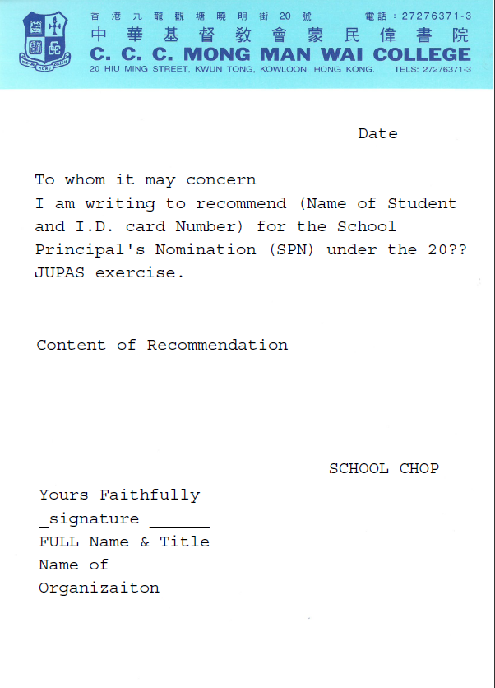
PART ONE Extra-curricular Activities (inside and outside school)
To be completed by applicant
Activities / Events / Achievements / Awards | Organization | Period | Role / Award | Page number, if any | Level (please tick)
 |  |  |  |  | International | Regional | School
Example: Student Association | MMWC | 1/9/2018-  30/6/2019 | External Vice-President | / |  |  | √
Example: HKUST Business Young Star | HKUST | 1/9/2018-  30/6/2019 | Participant | Page 1 |  | √
Example: Inter-school Athletics Championships – A grade Long Jump | Hong Kong Schools Sports Federation | 2019-2020 | 2nd Runner Up | Page 2 |  | √
Example: International Students’ Visual Arts Contest cum Exhibition of Hong Kong | Arts Education Section of EDB | 8/2019 | Finalist Certificate | Page 3 | √
Those which demonstrate Creativity
1.

2.

3.

4.

5.

Those which demonstrate Art Talent
1.

2.

3.

4.

5.

Those which are related to Community services
1.

2.

3.

4.

5.

Those which demonstrate Leadership
1.

2.

3.

4.

5.

Those which demonstrate Music Talent
1.

2.

3.

4.

5.

Other Cultural Activities
1.

2.

3.

4.

5.

Those which demonstrate Sports Talent
1.

2.

3.

4.

5.

Others
1.

2.

3.

4.

5.

PART THREE Declaration & Signature

□ Documents attached? ___ No ____ Yes (Total: _____ pages, excluding application form)
Applicant’s signature Parent's Signature

Date: ________________ ____________________ ____________________

Applicant’s Name Parent's Name

____________________ ____________________

